Troubleshooting the Caterpillar 3116 Fuel System
(1) Found the fuel solenoid on the fuel pump and make sure it clicked open when the key was turned on.
Put about 5psi of air pressure in the tank and check for fuel leaks, and found none.
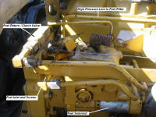  (1) CAT 3116 Fuel System | 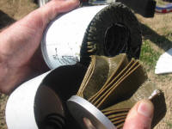  (2) Fuel Filter Autopsy
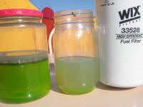  (3) Fuel Samples; Left is from  the bottom of the fuel tank, and  right is out of the fuel filter. | 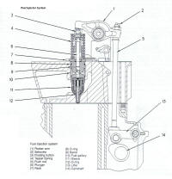  (4) Caterpillar mechanical fuel  injector detail.

(2) Disconnected the fuel out line from the tank a took a sample of the fuel, and also took a sample from the fuel filter and cut the filter apart to look for debris.
(2) This was some worrisome looking diesel. I am completely stumped as to what the white stuff is floating on the fuel tank. I the posted the photo the Yahoo origamiboats group. Turns out only the top layer is diesel with lots of water in it, and the bottom layer is mostly antifreeze.
So now I'm wondering what idiot put antifreeze in the fuel tank. I printed out the photo and took it to MHC, a local truck service station and and Ernie confirmed it was water. When I told him it was from a CAT 3116 he immediately asked if it had used more coolant lately.
(4) The 3116 as well as other CAT engines use mechanical injectors. They are located between the intake and exhaust valves and the work on the same principle. A push tube pushes a rocker arm and the other side of the rocker pushes on the top of the injector which compresses the fuel that is then injected into the cylinder. The fuel is delivered to each injector through a passage that is drilled though the center of the head. Because the work to compress the fuel is done at the injector the the fuel pressure from the pump and through the rail is only 29 to 58 psi depending on the engine speed. The coolant too of course travels through the head and actually passes around each injector that is sealed only by a thin brass sleeve which is pressed into the head. When the sleeve cracks or comes unsealed the fuel leaks into the coolant when the coolant pressure is low, and coolant leaks into the fuel when the coolant is hot and the pressure is high.
With some water in the fuel the engine was hard to start, but once the tank had an inch of antifreeze in the bottom, then nothing but antifreeze was being delivered to the engine and she died completely.
I cleaned out the fuel tank. Then filled a hose full of clean fuel and connected one end to the fuel line out from the filter and the blew air into the other in order to push clean fuel through the pump and rail. With the return line directed into a beer bottle I could get the engine to run just enough to move her out of the way until I get my gantry built when and can then pull the engine.
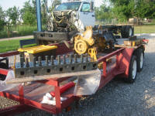
The gantry made easy work of
lifting the cab, pulling the engine
and replacing the head with a
remanufactured head.

June 2008 - The gantry is up now and the engine is out. After a few evenings of disconnecting and labeling things for their inevitable reconnection we lifted the engine out of the truck. I then then rolled it around on the gantry until my neighbor Travis told me to stop showing off. I cobbled together a quick engine stand and set her down on a trailer so I can later drive her to a real mechanic in order to set the fuel injector control rack and valve settings.
After much discussion we decided to get a remanufactured head. The brass injector sleeves can be remove and new ones pressed back in, but that is another special CAT tool and the estimated hours brought the price to the same as the $800 remanufactured head. Add on 6 injectors, 3 destroyed injector push rods and rod adjuster ends, a new injector control rack as recommended, along with gaskets. The total damage was $2145 plus tax. The 3 destroyed injector push rods are likely due to the injectors locking up, because of the water. Luckily the rocker arms for the injectors appear to be in good shape. We first tried to get the injectors tested, but no one locally had the proper test equipment.

Setting the Fuel Injectors
With the new head bolted on the injector control rack and valve rockers arms are next and then it is time to adjust everything. If you have a fleet of CAT 3316's you will want the $1200 tool kit for setting the injectors. Or you can take it to a mechanic with the proper tools or you can take it to do what I did, and find an experienced diesel mechanic that says he can do it without the kit. That is the guy that might teach you something that could come in very handy.

Governor and the Fuel Control Ratio
The throttle cable connect to the governor and the governor connects to the fuel injectors. The governors job is to smooth out throttle increases so too much fuel is not dumped into the cylinder before the rpm's and turbo charger have caught up to the higher speed. In order to this trick the governor has a tube connected to the intake manifold and that moves a diaphragm attached to an arm the limits the travel of the injector control rail. As the intake pressure increases the diaphragm moves and the fuel slowly increases. The Fuel Control Ratio is an adjustment of how far behind the injectors are compared to where you have the throttle peddle. You can test the diaphragm by removing small meal tube that runs from intake manifold to the side of the governor. Apply 20 to 30 psi of air pressure to the fitting in the governor. If the engine is in working order you can snap the throttle back and forth while you watch the exhaust. With air applied you should get a big bloom of black smoke and without air applied not much smoke. If the engine is not running then testing the governor requires a special tool. If the governor is out of adjustment CAT has a special bench test set, of course.

Fuel Injector Synchronization
John Whelan's blog: http://SchoolBusMechanic.blogspot.com is a great resource for diesel work and John is good about answering questions. If you have the special tools from Caterpillar then John's site is exactly what you need. If you do not have the special tools it will show you what you will have to do without.
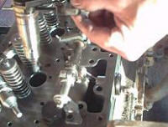
(1) Movie - How the injector
control rail works.
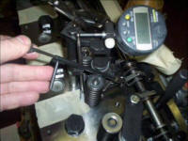
(2) John Whelan describes how
to adjust the the injectors with the
proper Caterpillar tools.
Movies: Part 1 Part 2 and Part 3
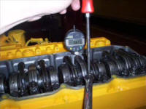
(3) John Whelan demonstrates
adjusting the fuel injector rocker.
Movie

The injector control rail sits below the rocker arms. You can reach it with the rocker arms in place, but it's easier to see and adjust with them off. (1) The control rail is linked to the governor, which is linked to the throttle peddle. So when you press the peddle down the cable pulls on the governor, and the linkage between the governor pulls on the control rail and the rail rotates. The rail has small adjustable arms for each of the 6 injectors. As the rail rotates each arm pushes a pin on the injector and increases the amount of fuel injected into the cylinder. The arm on the injector control rail for the number one injector at the front of the engine is not adjustable.
On new undamaged injectors, you have to compress the injector spring slightly in order to move the control rod. The CAT kit comes with hold downs that temporarily bolt into the head and compress the springs. A piece of flat bar will do if you don't have the kit.
(2) When using the kit from CAT, there is a fixture that you install against the rail at the number one injector. Then you just make sure that the gap between the stops is 1.25 and 2.25 mm. After that you check the other injectors and adjust the arm on the rail if needed so that movement on the control rod passing thought the injector is 3.50 mm.
The tool that actually adjust the arms on the control rail can be substituted by a small box end wrench and an allen wrench.
If you don't have the CAT tools for the fuel injection synchronization, then you might be able to take it to a local diesel mechanic who has the kit. In Tulsa Oklahoma I found 2 shops with the kit.

Warren Caterpillar, of Tulsa Oklahoma --Sucks
I took my engine to Warren Caterpillar and spoke to the service manager, explaining that I just needed the synchronization done on a new control rail on a remanufactured head and that I figured it would take less than a hour, having watched John Whelan's video's. Just the just the synchronization, no need to set the valve lash or the injector timing, that I could do that. "Don't believe everything you see on the Internet" I was told by the service manager. Then I was told that he had done hundreds of these and I would need to have the injector seats reamed even though the head was remanufactured and the manual says reaming in not needed on new sleeves. I was told the governor's fuel control ration would have to be set even though it can only be checked, and there is no reason for it to have a problem since it was working fine before. And I was told that the intake manifold had to be installed even thought John Whelan clearly does not have the intake manifold on. Finally I was told that it would be three to four days before they could do it. ...I left with my engine.
The second option in Tulsa was no better. John Kaiser is a renown diesel mechanic. When I finally got him on the phone I explained what I needed and he said it would take no less than four hours. I didn't bother explaining about John Whelan's video, after all you can't believe everything you see on the Internet. I thanked him and hung up.
Thoroughly pissed off now I decided to wing it. You can't harm anything by not having the synchronization correct. If I can get it running I can likely tune it by trial and error and in the worst case I can limp it into the Caterpillar shop and get raped.

Fuel Injector Synchronization and Injector Timing Without Caterpillar Special Tools - Maybe/Almost!
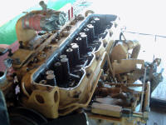  (1) Intake manifold | 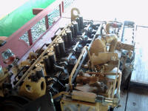  (2) Intake manifold removed.
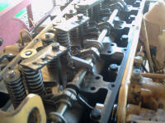  (3) Bits of steel using the rocker  arm assembly bolts to slightly  compress the injector springs. | 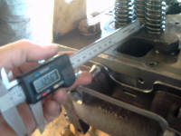  (4) Measuring the distance the  injector control rod sticks out the  back of the injector.
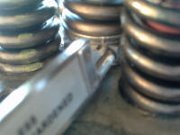  (5) Close up of injector rod and  caliper. | 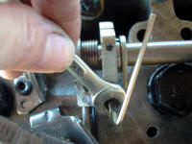  (6) Adjusting the CAT injector  synchronization.
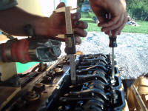  (7) Setting the injector timing is  simply a matter of using a  caliper to measure the height of  the injector's spring. | 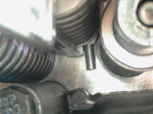  (8) Injector timing measurement.

I compared the old rail to the new rail and they are nearly set up the same. Synchronization implies uniform movement, so from the sound of it the only thing that needs to be done is to insure that the injector control pin on the number 2 thru 6 injectors match the number 1 injector that is factory set.
(1) (2) The first step was the take the intake manifold back off. The coolant thermostat housing also needed to be removed.
(3) In order to allow the injector control pins to move without damaging the injectors it is necessary to slightly compress the injector springs. I cut 6 bits of steel from scrap and drilled them with a hole that would just fit the bolts borrowed from the rocker arm assemblies. With all 6 in place the injector control rail is free to move.
(4) (5) I first locked the control rail with a pair of vise grips. Then using an inexpensive digital caliper that has a tongue to measure gaps on the end of the slide, I measured how far the injector control rod was sticking out the back side of the number 1 injector. Then it was just a matter of making sure the rest of the injectors matched that distance.
(6) Only two of the injectors needed an adjustment, and that was only 1/8 of a turn. The adjustment is easily made with a 7 mm wrench and an allen wrench. This would not be possible with the rocker arm assemblies in place.
The entire process took me less than 30 minutes. Shame on you Caterpillar mechanics that insist on 4 hours! Learn to earn your money instead of stealing it.
With the injector synchronization completed the rocker arm assemblies can be installed and the valve lash set. The injector timing is set while you are setting the valve last for each cylinder. (7) The caliper can again be used to avoid the CAT dealer and the special tool. The Injector timing will be printed on the valve cover. Mine is 63.94 mm. (8) You simply measure the distance from the top of the spring to the top of the metal seat at the bottom of the spring. The distance is adjusted with the screw on the other side of the rocker arm. Once it is correct, just tighten the lock nut and check the distance again.
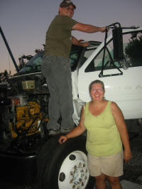
(9) Travis and Kay enjoying the
sound of success.

Once back in the truck (full story below), we put the peddle on the floor and turned her over for 40 seconds at a time, resting a few minutes between goes. We watched the fuel return line that was diverted into a jar just to check for progress. On the 6th time, one or two cylinders started to fire and we got smoke out the exhaust and just drops from the return line. By the 8th go, she was banging on 3 cylinders, flowing fuel with lots of air and she kept running on her own. Over the next 3 minutes the other cylinders joined the chorus, the smoke cleared and she was running like a champ. When we got the clutch installed correctly we ran her down the highway and the performance now is fantastic. She had no trouble at all reaching 75 mph. On a 200 mile trip to Oklahoma City and back with 2500 pound of paint she got 12.2 mpg. The idle is too high and she has white smoke when started so there are still some adjustments left to do on the governor.
(9) Much thanks goes to our neighbor Travis who is rarely short on good advice when it comes to working on engines.

Engine Installation
Lifting and moving the engine around with the gantry is easy, but getting it to go back onto the transmission drive shaft has now failed on three separate attempts. The transmission drive shaft has splines that pass through inter splines on the clutch plate. This allows the clutch plate to move forward and backwards as it is compressed into the flywheel. My problem was with the tip of the transmission drive shaft that is simply smooth and round and which is suppose to slip into a pilot bearing on the flywheel. Unfortunately once the drive shaft spines have passed though the clutch splines it is easy to move the clutch sideways so that it no longer is lined up with the pilot bearing. Even when you align the bell housing to the clutch housing on the back of the engine and put all of the bolts in place, there is still enough play in the drive shaft that you will not get the alignment back to the center.
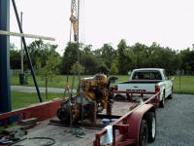
Transmission suspended from
hoist in order to aligned the drive
shaft with the clutch and pilot
bearing for easy installation.

Plan "B" - Is to removed both the transmission and the engine from the truck; assemble them in the light of day, and install them already joined together. Note: the transmission must be 400 pounds so try not to drop it on your chest. A transmission jack would be really nice, but in a pinch some tie down straps will do. While I was that far into it I took the clutch plate in to check it for wear and strung $8 for a clutch alignment tool.
Plan "B" was a success. With the engine on it's stand, the transmission was suspended from two hoist so the drive shaft could be aligned with the clutch and pilot bearing. With a few adjustments the transmission slid on easily. The whole unit was then dropped effortlessly back into the truck. By just standing on the front crankshaft pulley, we could counter balance the transmission and set the engine directly onto its' mount. The next time the engine comes out again, it will definitely come with the transmission too.

Eaton Transmission Pull-Type Clutch Installation
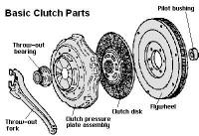  Standard Clutch Parts | 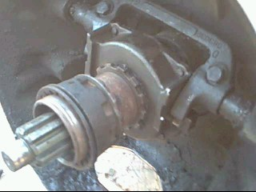  Movie: Pull Type Clutch  How not to remove!
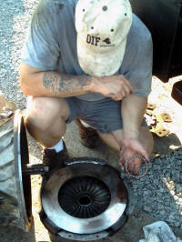  Trying to figure out how to get  the retainer ring back on the  throw out bearing. | 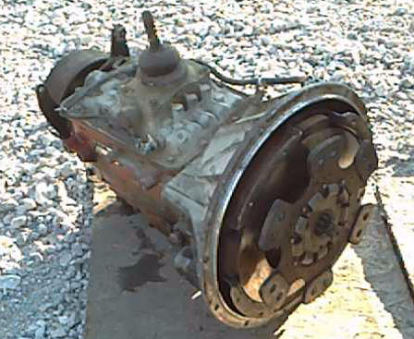  Movie: How a Pull Type Clutch  Works.

While putting the transmission back on the engine I could not understand how the clutch was suppose to work. The diagram and assembly instructions in the manual were no help and even Travis my neighborly mechanic was stumped. Being more worried about the engine than the clutch I decided it worked by magic and proceeded to put it back together as it was. The key to the problem I discovered later was that this was a "pull-type" clutch. The clutch arm pulls the "throw out bearing" away from the "diaphragm springs" on the clutch pressure plate. So the flange on the throw out bearing does not push on the springs, it pulls on them. That means that the flange on the throw out bearing needs to be on the clutch disk side of the springs. As the bolts holding the pressure plate to the flywheel are tightened, the springs diaphragm springs close together. That allows the flange on the throw out bearing to pass through the springs while the bolts are loose, and then be trapped when the bolts are tightened down.
I took the pressure plate and throw out bearing to a clutch shop for a checkup. Most of the time they see this done the pressure plate springs are damaged but mine look fine.
With considerable pressure and a little banging with a hammer I convinced the retainer ring to onto the throw out bearing. Then the clutch and clutch pressure plate were aligned with an $8 clutch alignment tool with the pilot bearing on the engine flywheel and bolted down. Finally the transmission was balanced on a floor jack and slid back into place. So pulling an reinstalling the transmission is not that difficult, but if the engine comes out again, the transmission is going to come with it.

Rear Main Transmission Seal
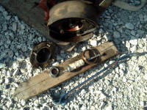
Rear main seal removed from the
transmission using a bolt to hook
in behind the old seal and pull it
out using a pry bar.

I thought that the rear main seal on the transmission was leaking because oil would pour out while we are moving the transmission around. It not a bad idea to replace the seal anyway but I later discovered that their is a small vent tube on the rear of this particular transmission. It is located behind the parking break and above the drive shaft. If you tilt the transmission at 15 degrees or so you will fill the tube with oil and then when you level it out again the oil will leak out of the tube down around the drive shaft.
Replacing the rear main seal required removing the rear drive shaft and pulling the drive shaft yoke off the rear of the Eaton transmission before we could reach the seal. It does not require removing the transmission; ours was just already sitting out. The seal must be pulled out without scratching the housing. To do this we ground down one side of the head of a bolt so the remaining portion of the head could slip past the seal and hook onto the back side of the seal. A pry bar was then used to pull on the exposed end of the bolt and draw the old seal out.

White Smoke Issue
The engine ran great for a 100 mile trip. Then is belched white smoke when started and ran rough until it warmed up and ran great for the 100 return trip. It's gotten colder now and the smoke and rough running problem has gotten much worse. It takes a minute of cranking to get it started when it's cold and it runs very rough for the first couple of minutes while belching smoke. After a few minutes the idle is good and the smoke is less until the rpm is increased. After it's warm the power power is good, and the rough running is limited to 1600 rpm and above which will still result in lots of smoke.
In order to test for compression leaks around the injectors you can install a section of clear hose in the fuel return line or even easier that that, you can disconnect the return line from the tank and stick it down inside of a glass jar. Have two glass jars and somebody to standing there to pour the full jar back into the fuel tank. You should see a very small stream of vapor bubbles but nothing big that would be exhaust gases. Mine checked out fine.
Then check for coolant in the return fuel. Best way to do this is open the drain plug on the bottom of the tank and catch the first of the runoff your glass jar. I did that and only had one drop of water; most likely from condensation and some grains of carbon.
I pulled off the valve cover and took another look at the adjuster between the governor linkage and the fuel synchronization rail. It requires another special CAT tool to loosen the lock nut so you can turn the allen screw. But get a three inch piece of 1/4" copper tubing and stick that down on the wrench end of a 1/4' socket and heat both with a torch until the copper tube slips into the socket. When it cools down you have your tool. Snap a pair of vice grips to the top end of the copper tube so you can loosen the nut, and use a long allen wrench to reach through the copper tube and the socket to turn the allen screw on the adjuster.
Of course I am adjusting this thing without the special CAT part that is used a gauge, but I was able to clear up lots of the smoke and get the engine to run smoother by turning down the fuel. This also lowered the idle to 800 rpm.
She runs good at road speeds, but there is still too much smoke when idling. Especially when it's cold. So I decided that it was time for a mechanic with the CAT tools to have a look. Turns out that I had the fuel set almost perfect, but the #4 injector was acting up.
So we are back from the shop after paying a $2045 dollars. $1500 of that was for 16+ hours for a CAT mechanic with CAT tools to sync the fuel system and replace 2 injectors. The theory is that those two injectors that they were defective or possibly damaged because the fuel system was not synced perfectly, however the mechanic was astounded that it was so close.
The truth? Who knows. I can sell the truck for $5000 and end up in the red by $3,661.60. An expensive diesel repair course but one that contained lots of valuable lessons.

Considering Buying a CAT Diesel?
I do not recommend any CAT diesel for your boat unless you plan to have a CAT mechanic around to work on it and never plan to go far away from your CAT mechanic. (If that is you then why the hell are you reading this page?) There is no other reason for their "special" tools and specifications that are only in the manuals the come with their special tools other than making it necessary for you to go back to them for service. We have firmly decided against CAT as an engine for our boat.

Other CAT 3116 Tips
To turn up the fuel, remove the valve cover and between #1 & #2 rocker stand will be a small jam nut and screw on the rack bar. To increase rack travel on the injectors turn the screw counter-clockwise.
To advance injection timing, break loose the injector lock nut on center rocker. Turn in the adjustment screw 3/4 of a turn. This should put you at advanced side of the spec for the engine injection combination which will provide better power and worse fuel economy.
To check the injector and cylinder condition, remove the valve cover and get engine up to operating temperature. With a screw driver go in from the exhaust manifold side and at the base of the injector is a small link rod that turns the barrel in the injector. You can manually push the small rod back towards the drivers side and place each cylinder at full fuel on, one at a time in order to detect how well each cylinder is doing. Also you can watch the blow-by tube for signs of something not up to par for that cylinder as well. The blow-by tube vents gases from the engine block that have leaked past the rings in the piston.
Check the muffler. You can disconnect the exhaust from the back side of the turbo and see if you are having problems with too much back pressure in the exhaust.

