WP7 Euro Ⅵ Vehicle Diesel Engine
Operation & Maintenance Manual and User Service Guide

610800820289

Foreword
WP7 Euro Ⅵ vehicle diesel engines are developed based on a new design concept and meet the Euro Ⅵ emission standard. WP7 diesel engines feature compact structure, reliable operation, high economy indexes and power performance, quick startup, easy operation and convenient maintenance and are the ideal power for the middle/heavy-duty trucks and middle/large buses.
This manual, as reference, describes methods of operation and maintenance, inspection essentials and service guide for WP7 diesel engines.
To make best use of WP7 diesel engines, users are expected to carefully read and learn the diesel engine structure, maintenance and operation methods. The diesel engine service life can be significantly prolonged if the users can follow this manual during maintenance.
With the increasing numbers and improving of the variants of WP7 vehicle diesel engines, users are expected to timely pay attention to the technical information released by Weichai. Any revision will not be notified in advance. For more information about new products, please visit http://en.weichai.com.

March. 2014
Special instructions
- It is very dangerous to increase the power by modifying the ECU data. Any change of ECU data without permit will lead to invalid “Three guarantees” and so on, and all losses and the legal responsibilities arising therefore would be borne by the users.
- Common-rail fuel pump, turbocharger, urea solution injection system and other components, as the precision parts, should not be impacted or dismantled without permission; otherwise the "Three guarantees" will be invalid.
- Please use Weichai designated fuel strainer and fine filter; otherwise any damage to the common-rail system will not be covered by the “Three guarantees”.
- For Euro Ⅵ Diesel Engine, in order to make sure the normal operation of the SCR processor, please add urea solution produced by formal manufactures timely. It is forbidden to use urea solution mixed privately or other solutions, otherwise, all losses and the legal responsibilities arising therefrom would be borne by the users.
- Please go to the formal fuel station to refill the stipulated fuel, otherwise any damage to the fuel system due to fuel quality will not be covered by the “Three guarantees”.
- For Euro Ⅵ diesel engine, special Euro Ⅵ diesel fuel should be used, otherwise any problems arising therefrom, such as the emissions exceeded the limits of standard, should be borne by the users.
- Any service such as repair or maintenance should be done at the designated service station and spare parts specified by Weichai Power should be used; otherwise, any damage to the diesel engines should be borne by the users.
- The product norm follows Q/WCG 100.
Notice
  - Before the first use, the engine should go through a 50h trial run. For more information, refer to the running-in requirements.
  - After the cold start, the engine should slowly increase the speed. Don’t let the engine run at idle speed for a long time or suddenly speed up. After running with heavy load, do not immediately stop. It is necessary to idle for 5-10 min at low speed.
  - It is prohibited to work without air filters which could prevent air from entering the cylinder without being filtrated. The air filter should be regularly maintained or replaced, otherwise power reduction, parts wearing and other problems would happen.
  - Please select specified grades of fuel and oil and use the special and clean containers. The fuel and oil should be filtrated with the strainer before being added.
  - If the diesel engine fails to start within 15s, repeat after at least 2 min.
  - It is prohibited to fill the diesel engine with water rather than antifreeze, which could greatly reduce the engine life and leads to damage of the after-treatment system and other parts.
  - Before the start, please ensure the antifreeze, urea solution and oil are at the proper levels.
  - The strainer of urea solution tank must be cleaned regularly, otherwise the OBD system will giving alarm.
  - When the vehicle is parked for a long time and the ambient temperature is lower than the freezing point of antifreeze, it is necessary to drain the water out through the discharge valve of the air compressor.
  - It is not allowed to reuse the cylinder head gasket and all kinds of asbestos or metal coated sheet gaskets.
  - Feedback of engine quality information
Our company performs the quality-trace filing for WP7 diesel engines, therefore users are expected to fill the card and send it back to our company for further service based on the card.
CONTENTS

WP7 Euro Ⅵ diesel engine outside view 6
The meaning of diesel engine model 7
Diesel Base Parameter 7
Tools and equipments: 8
I. Operation & Maintenance Manual for WP7 Euro Ⅵ Vehicle Diesel Engines 1
1 Fuel, lubricating oil, antifreeze and auxiliary material for the diesel engines 1
1.1 Fuel 1
1.2 Lubricating oil 1
1.3 Antifreeze 2
1.4 Urea Solution 2
1.5 Features of Weichai Power special oil 3
1.6 Difference between the Weichai Power special oil and common oils 4
1.7 Some Common Products of Weichai Power Special Oils 5
1.8 Corresponding table between the Weichai Power special oil and engine models 5
1.9 How to select proper viscosity 6
1.10 Auxiliary materials 6
2 Regular inspection and maintenance of diesel engine 7
3 Common failures and Troubleshooting 12
II. User Service Guide (warranty card) 21
Weichai Power Product Warranty Card (Kept by user) 21
Service Registration Form (filled by the service staff) 22
Warranty Explanations 23
“Three guarantees” period for diesel engine of Weichai Power 26
Weichai international marketing service network 27
The European Union representative office 28
Diesel engine mandatory maintenance card 30
Customer Satisfaction Questionnaire 33

WP7 Euro Ⅵ diesel engine outside view
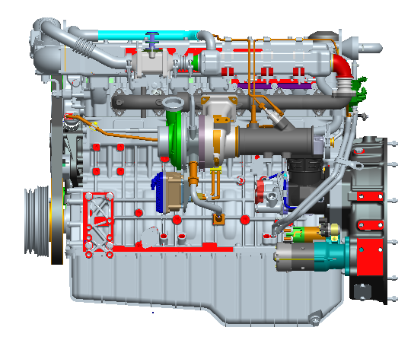
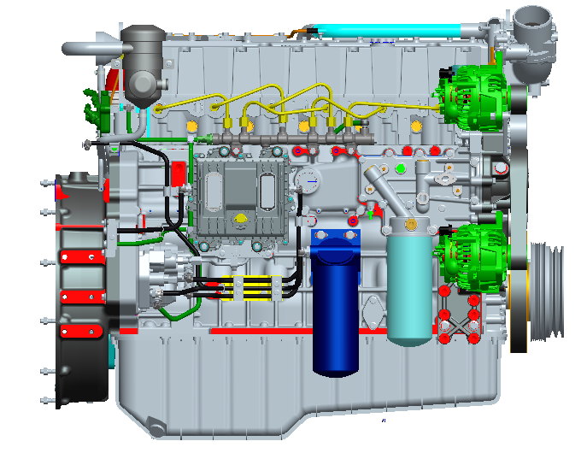

The meaning of diesel engine model
WP 7 . 270 E6 1
transmutation type

emission level
E6 stands for Euro Ⅵ emission
rated power (horsepower)
space, no meaning
displacement
Weichai Power company

Diesel Base Parameter
the Parameter of WP7 Euro Ⅵ diesel engine
Model | Unit | WP7.270E61
Type |  | 6 cylinder Inline
Intake |  | TDI
Bore × Journey | mm ×mm | 108×136
displace | L | 7.47
Rated power/ speed | kW/r/min | 199/2100
BSFC @rated speed | g/kW∙h | 205
Max torque/speed | n∙m/r/min | 1050/1200~1700
Max speed | r/min | 2500±50
Idle speed | r/min | 700±50
Fire order |  | 1-5-3-6-2-4
Noise | dB(A) | ≤118
weight | kg | 700±20
Life of B10 | km | 800,000
Period of oil change | km | 20,000

Tools and equipments:
torque wrench | sleeve wrench | adjusted wrench
depth gauge micrometer | piston ring plier | dial indicator
screwdriver | copper hammer | orientation sleeve
pressure oil spot | filler gauge | diameter gauge micrometer

I. Operation & Maintenance Manual for WP7 Euro Ⅵ Vehicle Diesel Engines

1 Fuel, lubricating oil, antifreeze and auxiliary material for the diesel engines

1.1 Fuel
Summer: use the #0 diesel fuel.
Winter: use the #-10 diesel fuel under general conditions, use the #-20 diesel fuel when the atmospheric temperature is below -15℃，and #-35 diesel fuel when below -30℃.
The fuel to be filled should meet the standard in appendix C.6 of national standard GB 17691-2005.

1.2 Lubricating oil
1.2.1 For WP7 Euro Ⅵ series diesel engines, use oil with higher grade than CI-4 or CJ-4.
1.2.2. It is allowed to use the oil of higher grade instead of oil of lower grade.
1.2.3 If the ambient temperature is -15℃ or higher, use the 15W/40 oil; if the ambient temperature is -15℃ or lower, use the 5W/20 oil.
(Weichai Power special oil should be used, see sections from 1.5 to1.8)
Before the startup of diesel engine, check the oil level in the oil sump.

1. Do not check the oil level during operation.
2. It is not allowed to mix the oils of different grades.

Table 1-1 Selection of oil grade
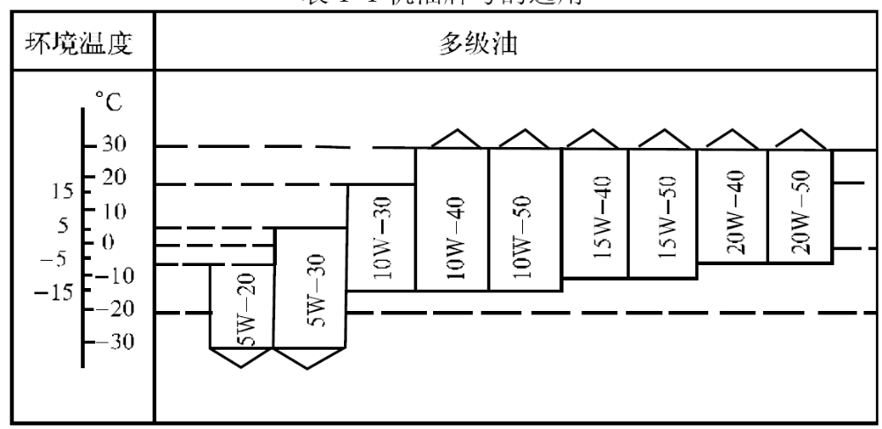
Ambient
temperature
Multi-grade oil
Due to the flat viscosity curve, the multi-grade oil has excellent lubricating characteristics at lower and higher temperatures.

1.3 Antifreeze
1.3.1 The cooling system should be filled with long-lasting antifreeze fro rust-proofing and antifreezing.
1.3.2 For the long-lasting antifreeze formulation, please refer to the instruction of antifreeze. Some domestic long-lasting antifreezes are shown in Table 1-2.
Table 1-2 Domestic long-lasting antifreeze.
Item Grade | JFL-318 | JFL-336 | JFL-345
Glycol content % | 33 | 50 | 56
Specific gravity (15.6℃) | 1.05 | 1.074 | 1.082
Boiling point ℃ | 104.5±1 | 108.5±1 | 110.0±1
Freezing point ℃ | -18±1 | -36±1 | -45±1
Applicable lowest temperature ℃ | -10 | -26 | -35

1.4 Urea Solution
Product Properties for urea solution as per the revised ISO22241 standard. See Table 1-3 for details.
Table 1-3 Requirements on Urea solution (Refer to ISO22241)
Items | Unit | Min limit | Max limit
Urea content | % by weight | 31.8 | 33.2
Density at 20℃ | kg/m³ | 1,087 | 1,093
Refracting index at 20℃ | - | 1.3814 | 1.3843
Alkalinity as NH₃ | % | - | 0.2
Biuret | % | - | 0.3
Aldehyde | mg/kg | - | 5
Insolubles | mg/kg | - | 20
Phosphate (PO₄) | mg/kg | - | 0.5
Calcium | mg/kg | - | 0.5
Iron | mg/kg | - | 0.5
Copper | mg/kg | - | 0.2
Zinc | mg/kg | - | 0.2
Chromium | mg/kg | - | 0.2
Nickel | mg/kg | - | 0.2
Aluminium | mg/kg | - | 0.5
Magnesium | mg/kg | - | 0.5
Sodium | mg/kg | - | 0.5
Potassium | mg/kg | - | 0.5

1.5 Features of Weichai Power special oil
1.5.1 High-qualified lubricating oil
Adopt fine imported hydrocracking base oil and composite additives to ensure the high quality of lubricating oil.
1.5.2 At normal use, the oil-change interval can be increased by 3,500~7,000km (10,000km for CH-4); excellent oxidation resistance at high temperature and excellent TBN retention will also prolong the engine life.
1.5.3 Professional protection to extend the engine life
Through a lot of performance and durability tests on Weichai diesel engines, a professional oil formula suitable for high power and high load engines is worked out. The special oil can provide the Weichai engine with special protection and can significantly prolong their service life (by 30~40% in contrast with others).
1.5.4 Better performance
It features of better wear resistance, TBN retention, anti-rust performance, antioxidation, better fuel consumption control, shear stability and can reduce sediments in the turbocharger.
1.5.5 Energy-saving
“Low viscosity + Multi-grade + Friction modifiers”, energy-saving formula, high oil viscosity index, high oil-film strength and elasticity, thus the engine can run stably with low resistance and low fuel consumption.

1.6 Difference between the Weichai Power special oil and common oils
Item | Special oil | Common oil
Base oil | Adopt the imported class IV hydrocracking basic oil. | Most oils adopt domestic class I base oil, a few adopt class II base oil
Additive | Mainly adopt the imported high-quality composite additive. | Domestic additive
Performance | With targeted professional formulation, the special oil features good lubricating and cleaning performance, and effectively improves the fuel economy (saving fuel by 3~8%) and provides professional protection for the diesel engine even in severe working conditions such as heavy load and dusty environment (heavy load or heavy dust) | Only meet the common lubricating requirements
Oil change interval | At normal use, it can be extended by 3,500~7,000km (for CH-4, 10000km can be extended). | Normal interval

1.7 Some Common Products of Weichai Power Special Oils
Type | Oil grade | Viscosity grade | Package capacity
Diesel engine oil | WP-E1(CD) | 15W/40  20W/50  10W/30 | 4L, 18L, 200L
Diesel engine oil | WP-E2(CF-4) | 15W/40  20W/50  10W/30 | 4L, 18L, 200L
Diesel engine oil | WP-E3(CH-4) | 5W/30  15W/40  20W/50  10W/30 | 4L, 18L, 200L
Diesel engine oil | WP-E4(CI-4) | 15W/40 | 4L, 18L
Gear oil of heavy-duty vehicles | GL-5 | 85W/90  80W/90 | 4L, 18L

1.8 Corresponding table between the Weichai Power special oil and engine models
Type | Special oil grade | Applicable engine models
High-speed diesel engines and high-power medium-speed diesel engines | WP-E1  (CD) | Medium-speed diesel engine sets
 | WP-E2  (CF-4) | China I and China II diesel engine; construction machineries such as 50 and 30 loaders; WD618/WD12 series, WD615/WD10 series; 226B and medium-speed engine; 15T or more heavy-duty trucks
 | WP-E3  (CH-4) | Euro Ⅵ diesel engines; Landing engine series; extra-large heavy-duty trucks and buses; WP4/WP6(165~270HP), WP10(240~375HP), WP12(336~460HP), WD10, WD12 and WP5/WP7(160~300HP)
Natural gas engine | CNG | Compressed natural gas engine; Coach, generator sets and others equipped with compressed natural gas diesel engines.

1.9 How to select proper viscosity
Lubricating oil | SAE Viscosity grade | Applicable ambient temperature (℃)
Lubricating oil | 5W/30 | -30~35
Lubricating oil | 10W/30 | -25~35
Lubricating oil | 15W/40 | -20~40
Lubricating oil | 20W/50 | -15~50
Gear oil | 85W/90 | -15~49
Gear oil | 80W/90 | -25~49
Gear oil | 85W/140 (viscosity higher than 85W/90) | -15~49

1.10 Auxiliary materials
The applicable positions are shown in the following table:
Table 1-4 Auxiliary materials for WP7 Euro Ⅵ diesel engines
S/N | Name | Color | Usage and Application
1 | Molybdenum disulfide, oil solution | Dark gray | Acting as a lubricant before the lubricating oil pressure is built up. For example: coated on the intake valve stem etc.
2 | Loctite 242 | Blue | Coated on the threads and outside surface of bearings to prevent against any potential looseness due to vibration, with medium strength.
3 | Loctite 262 | Red | Coated on the outside surface of threads, playing the role of locking, sealing and resistance to looseness due to shock, with high strength.
4 | Loctite 275 | Green | Coated on the pipeline and connection portion
5 | Loctite 510 | Red (Orange ) | Coated on the shiny metal surface to function as sealing. For example: the joint faces of the cylinder block and flywheel housing.
6 | Loctite 277 | Red | Suitable for sealing the space between core and hole and applied to the oil chamber and oil passage, such as the cylindrical surface of bowl-plug.
7 | (Loctite 648) | Green | Coated on the shining metal surface to function as fixing, such as the inside hole of tensioning bearing and outside surface of the shaft etc.

2 Regular inspection and maintenance of diesel engine
Table 2-1 Working conditions of matched vehicles
(WG I) | (WG II) | (WG III)
Working under severe conditions (extremely cold or hot; dusty; short distance transport; working on construction site and city buses, municipal construction vehicles, snow sweeper vehicles or fire trucks) or annual mileage is less than 20,000 km or annual working hours is less than 600h | Annual mileage is less than 60,000 km; short or medium distance transport (goods transport) | Annual mileage is longer than 60,000 km; long distance transport
Table 2-2 Intervals for 1st inspection, regular inspection and maintenance
Working  condition  Item | (WG I) | (WG II) | (WG III)
1st inspection | Having traveled 1,000-1,500km or having worked for 30-50h | Having traveled 1,500-2,000 km | Having traveled 1,500-2,000 km
Regular inspection | Every 5,000km or every 150h | Every 10,000 km | Every 15,000 km
Grade 1 maintenance | Every 10,000 km or every 300h | Every 20,000 km | Every 30,000 km
Grade 2 maintenance | Every 20,000 km or every 600h | Every 40,000 km | Every 60,000 km
Grade 3 maintenance | Every 40,000 km or every 1,200h | Every 80,000 km | Every 120,000 km
Grade 4 maintenance | Every 80,000 km or every 2,400h | Every 160,000 km | Every 240,000 km

Table 2-3 Oil changing interval according to vehicle maintenance specifications
Working  condition  Item | (WG I) | (WG II) | (WG III)
Working  condition  Item | Annual mileage less than 20,000 km | Annual mileage less than 60,000 km | Annual mileage longer than 60,000 km
1st inspection | Having traveled for 1,000-2,000km | Having traveled 1,500-2,000 km | Having traveled 1,500-2,000 km
P | Every 5000km | Every 10,000 km | Every 15,000 km
WD1 | Every 10,000 km | Every 20,000 km | Every 30,000 km
WD2 | Every 20,000 km | Every 40,000 km | Every 60,000 km
WD3 | Every 40,000 km | Every 80,000 km | Every 120,000 km
WD4 | Every 80,000 km | Every 160,000 km | Every 240,000 km

Table 2-4 Oil changing intervals determined by oil working condition (changes with the oil consumption)
Normal oil working condition (at normal oil consumption) |  | Severe oil working condition (at normal oil consumption)
Ambient air temperature: -10℃ to +30℃  Sulfur content of fuel: less than 0.5%  (by weight) |  | A | Tropical or frigid zone (temperature is always higher than +30℃ or lower than -10℃)
 |  | B | Sulfur content of fuel: 0.5%-1.0%
 |  | C | Sulfur content of fuel: 1.0%-1.5%
Oil working condition | Working condition
Normal condition | WG I  WG II  WG III | Every 5,000 km  Every 10,000 km  Every 15,000 km
Severe condition A | WG I  WG II  WG III | Every 5,000 km  Every 5,000 km  Every 5,000 km
Severe condition B | WG I  WG II  WG III | Every 5,000 km  Every 5,000 km  Every 10,000 km
Severe condition C | WG I  WG II  WG III | Every 5,000 km  Every 5,000 km  Every 5,000 km
Severe condition A+B | WG I  WG II  WG III | Every 5,000 km  Every 5,000 km  Every 5,000 km
Severe condition A+C | WG I  WG II  WG III | Every 2,500 km  Every 2,500 km  Every 2,500 km

Table 2-5 Maintenance specification of the engine

Item | 1st inspection | Regular inspection | Level 1 maintenance | Level 2 maintenance | Level 3 maintenance | Level 4 maintenance
Change oil (at least once per year) | ● | ● | ● | ● | ● | ●
Replace the oil filter element | Each time when changing diesel engine oil
Inspect and adjust the valve clearance | ● |  | ● | ● | ● | ●
Replace filter element of the fine fuel filter |  |  | ● | ● | ● | ●
Wash coarse fuel filter or replace the element |  |  | ● | ● | ● | ●
Inspect coolant amount and add to required amount | ● | ● | ● | ● | ● | ●
Change the coolant | Once a year
Tighten clips on cooling pipe | ●
Tighten air inlet pipe, hose and flange connections | ● |  | ● | ● | ● | ●

Item | 1st inspection | Regular inspection | Level 1 maintenance | Level 2 maintenance | Level 3 maintenance | Level 4 maintenance
Inspect maintenance indicating light or indicator of air filter |  |  | ● | ● | ● | ●
Wash the dust cup of air filter (excluding the auto dust-removal type) |  | ● | ● | ● | ● | ●
Wash the air filter main element | When the indicator is on
Replace the air filter main element | Please refer to related regulations in the vehicle instruction manual
Replace the air filter safety element | After the main element has been washed for 5 times
Inspect and tighten the belt | ● | ● | ● | ● | ● | ●
Inspect the clearance of turbocharger bearings |  |  |  |  |  | ●
Note: ● indicates that maintenance is required.
Engine shut down and stored for more than 6 months shall be maintained as required. Suggestion or advice will be given based on the user’s requirements.

3 Common failures and Troubleshooting
3.1 The engine fails in starting
Causes | Troubleshooting
1. Fuel pipe is blocked | Check and remove the blockage and check if the fuel is clean
2. There is air in the fuel system | Release the air and check air tightness of joints
3. High pressure fuel pipe is damaged and fuel leaks out | Repair it or replace it with a new one
4. The ambient temperature is too low | Use auxiliary start device
5. There is few fuel or no fuel left in the tank | Check and refuel
3.2 The engine stops soon after starting
Causes | Troubleshooting
1. Fuel filter is blocked | Disassemble the filter to clean and dry the inside; or replace it if necessary
2. There is air in the fuel system | Check the tightness of fuel pipes and the joints; check if the bleed screw is tightened; release the air
3. Fuel is of poor quality, containing too much water | Wash the filter and use high quality fuel
3.3 Engine Power is insufficient
Causes | Troubleshooting
1. Air inlet pipe is blocked (air filter is blocked) | Check and clean the air filter and air inlet pipe or replace the element
2. Exhaust back pressure is high | Check if the exhaust pipe is blocked
3. The pressure of turbocharging system is insufficient | Check and remove any leakage with the exhaust pipe
4. Fuel pipe leaks or is blocked | Check the tightness of fuel pipes and the joints; check the fuel pipes and check if the filter is dirty; Repair or remove any blockage; replace the filter element
5. Poor fuel quality | Wash the fuel tank, filter parts and fuel pipes; replace the fuel
6. High oil level | Release the extra lubricating oil

3.4 High fuel consumption
Causes | Troubleshooting
1. Air inlet pipe is blocked  (air filter is blocked) | Check the air filter and air inlet pipe to ensure smooth air-inlet
2 Exhaust back pressure is high | Check the exhaust pipe and braking valve to ensure smooth exhausting
3. Poor fuel quality | Replace the fuel as specified
4. Fuel pipe is blocked | Check and remove the blockage
5. Fuel pipe leaks | Check the leaking location and replace the pipe to ensure good sealing performance
3.5 Dark smoke in the exhaust
Causes | Troubleshooting
1. Air inlet is blocked or exhaust back pressure is high | Check the inlet and exhaust pipe to ensure the pipes are not blocked
2. Poor fuel quality | Wash and replace
3. Wrong valve timing or injection timing | Adjust as required
4. Injection pump injects too much fuel | Check and adjust (by specialized operator)
5. The pressure of turbocharging system is insufficient | Check if there is any leakage with the pipes and joints
6. Malfunction of turbocharger | Check and replace the turbocharger assembly
7. Intercooler is damaged or there is leakage | Replace or repair
8. Wrong working point of smoke limiter | Re-adjust (by specialized operator)

3.6 White or blue smoke emission
Causes | Troubleshooting
1. Poor quality fuel that contains too much water | Change the fuel
2. Coolant water has low temperature | Check working temperature of the thermostat or replace it when necessary
3. Wrong valve timing or injection timing | Check and adjust
4. Injector nozzle poor atomization | Check and repair
5. Low compression pressure, incomplete combustion or cylinder scuffing | Check the piston ring, cylinder liner and cylinder head gasket and repair them
6. Poor running-in between piston rings and the cylinder liner | Running-in for more time
7. Openings of piston rings are not staggered | Adjust or re-assemble
8. Piston oil ring failure | Replace
9. Excessive clearance between the piston and cylinder liner | Repair or replace
10. Sealing ring of turbocharger is worn | Repair or replace
11. Turbocharger thrust bearing is worn | Check and replace
12. Turbocharger oil outlet pipe is blocked | Wash or repair

3.7 Unstable speed
Causes | Troubleshooting
1. Poor quality fuel, containing too much water or wax | Clean the fuel system and replace the fuel
2. Air comes into the fuel suction pipe | Check the tightness of fuel pipes and the joints; release the air
3. Governor weight and spring do not work normally | Check and repair (by specialized operator)
4. Uneven fuel supply | Check and adjust (by specialized operator)
5. Poor atomization of the injector nozzle | Check and repair
6. The turbocharger surges | Check the compressor flow passage and remove the blockage, remove the carbon deposit in the exhaust path
7. Turbocharger bearing is broken | Replace
3.8 Low oil pressure
Causes | Troubleshooting
1. Low oil level in the oil sump or lack of oil | Check the oil level and leakage; repair and add oil
2. Failure of pressure regulator in the main oil passage | Check, clean and repair the valve
3. Oil strainer, oil pipe, joint gaskets are blocked or broken | Check the oil strainer and joints, repair the casting shrinkage porosity if any
4. Unqualified oil grade | Replace with qualified grade
5. Oil inlet pipe of the engine oil pump leaks | Examine the oil pipe, joints; repair or replace
6. The temperature of water in cooling system is too high, and temperature of lubricating oil is too high | Check the working conditions of cooling system, and correct
7. The resistance of oil filter is too big | Replace with a new element
8. Oil cooler is blocked | Check and remove the blockage
9. The main oil passage is blocked | Check and remove the blockage
10. Excessive bearing clearance or the bearing is damaged | Check and repair
11. Excessive wear of parts, overhaul is required | Check the working hours of the engine and carry out an overhaul
3.9 High temperature of cooling water
Causes | Troubleshooting
1. Low water level in water tank | Check if there is any leakage and add water
2. The water tank is blocked | Check the water tank to clean or repair
3. The water pump belt is loose | Tighten the belt as specified
4. Water pump gasket is damaged and the pump impeller is worn | Check and repair or replace
5. The thermostat failure | Replace
6. The water pipe is broken and air comes into the pipe | Check the water pipe, joints, gaskets, etc; replace the damaged ones
7. Low oil level in the oil sump or lack of oil | Check the oil level and leakage; repair and add oil
3.10 Early wearing of parts
Causes | Troubleshooting
1. Unqualified or damaged air filter element | Check, replace with a qualified element
2. Short-circuit of the air inlet system | Check the air inlet pipe, gasket, connecting sleeve, repair or replace
3. Low oil level in the sump or lack of oil | Check the oil level and leakage; repair and add oil
4. Oil passage is blocked | Remove blockage in the oil passage
5. Unqualified oil grade | Change the oil as specified
6. Piston ring is broken or worn | Replace the damaged parts
7. Cylinder liner or piston is worn or scuffing | Disassemble the piston and cylinder liner, repair or replace;
8. Oil filter element is not replaced in time | Replace as required
9. Excessive wear of parts, requiring overhaul | Check the mileage and determine to carry out overhaul
10. The crankshaft is not coaxial with the main shaft of driven parts | Check the mounting bracket, and repair if necessary
11. Unqualified oil | Adopt oil of right grade

3.11 Loud noise
Causes | Troubleshooting
1. Poor fuel quality | Replace the fuel
2. Cooling water has low temperature | Check the thermostat or replace it if necessary
3. Wrong valve timing or injection timing | Adjust
4. Injector nozzle has poor atomization | Check and repair
5. Injection pump injects too much oil | Check and adjust (by specialized operator)
6. Shock absorber is damaged | Check if the absorber is damaged; check the connecting bolts and replace them if necessary
7. The valve has leakage or improperly adjusted | Disassemble the valve and adjust
8. Too large gap between gears or some tooth is broken | Check and replace the damaged parts
9. Cylinder liner or piston is worn or scuffing | Check, repair or replace
10. Push rod is bent or broken | Replace
11. Piston ring is broken or worn | Replace
12. Bearing is worn seriously | Replace
13. Excessive crankshaft thrust bearing clearance | Replace
14. Main bushing is not concentric | Replace
15. The crankshaft is not coaxial with the main shaft of driven parts | Check the bolts on the mounting bracket and repair
16. Parts are worn seriously, requiring an overhaul | Overhaul
17. Turbocharger surges | Remove dirt and blockage in the compressor flow passage and accumulated carbon in the exhaust path
18. Sealing ring of the turbocharger is burnt | Replace
19. Turbocharger bearing is damaged; moving part rubs against fixed part | Replace
20. Foreign matters come into the turbine or the compressor impeller of turbocharger | Replace
3.12 The starter motor does not work
Causes | Troubleshooting
1. The battery is not fully charged | Examine, charge or replace the battery
2. Wires are nor well connected | Well connect the wires
3. Fuse is burnt | Replace the fuse
4. Electric brush has poor contact | Clean the bush surface or replace the bush
5. The motor itself is short circuited | Repair the motor or replace the assembly
3.13 The generator does not work at all
Causes | Troubleshooting
1. Wires are open or short circuit or the connectors are loose | Check the wiring of the generator and ampere meter and repair
2. Rotator and stator coils are open or short circuit or grounded | Repair or replace the assembly
3. Rectifier tube is damaged | Replace the assembly
4. The paper insulation of the terminal post is damaged, the wire is disconnected | Repair
5. The voltage of adjustor is too low | Repair
6. Contacts of adjustor are burnt | Repair or replace the assembly
3.14 Undercharged generator
Causes | Troubleshooting
1. Wires are open or short circuit or the connectors are loose | Repair
2. Rotator and stator coils are open or short circuit or grounded | Repair or replace the assembly
3. Generator belt is loose | Repair and adjust the belt tension
4. Damaged generator rectifier tube or poor contact of brush | Repair
5. The voltage of adjuster is too low | Adjust
6. Disconnected field coil or resistor wire of the adjuster | Repair or replace
7. Insufficient electrolyte or the battery is old | Add electrolyte or replace the battery
3.15 Unstable generator charging current
Causes | Troubleshooting
1. The stator or rotor coil is about to open or short circuit | Repair or replace.
2. Poor contact of brush | Repair
3. The terminal is loosened with poor contact | Repair
4. The voltage adjuster is damaged | Repair
5. The voltage is improperly adjusted | Check and adjust.
3.16 Overcharged generator
Causes | Troubleshooting
1. Internal short circuit of battery | Repair or replace
2. High adjuster voltage | Repair and adjust
3. Poor grounding of adjuster | Repair
4. Contact failure or contamination of adjuster; the voltage coil or resistor wire is open | Repair or replace
3.17 Abnormal generator sound
Causes | Troubleshooting
1. Improper installation of generator | Repair
2. Damaged bearing | Replace the bearing
3. Moving part interferes with the fixed part | Repair or replace
4. Rectifier short circuit | Replace
5. Stator coil short circuit | Repair or replace
3.18 Abnormal pressure of the urea solution pump
Causes | Troubleshooting
1. The filter element of urea solution pump is blocked | Wash or replace the filter element
2. Poor urea solution quality, containing too much impurity | Replace the urea solution and wash the urea solution tank
3. Urea solution nozzle is blocked | Replace

3.19 Abnormal indication of the urea solution level
Causes | Troubleshooting
1. Liquid lever sensor of urea solution-tank is failure | Check and replace
3.20 Urea-crystal appear at the nozzle position on the exhaust pipe
Causes | Troubleshooting
1. Wrong urea solution nozzle mounting size | Check and adjust
2. The nozzle has leaked | Check and replace

II. User Service Guide (warranty card)

Weichai Power Product Warranty Card (Kept by user)
Item | Content | Item | Content
Model |  | User’s name
Order No. |  | Zip code
Number: |  | Address
Purchasing date |  | Office phone
Distributor |  | Home phone
Respected users:
Thank you for using Weichai products, and we appreciate your trust! In order to correctly use and maintain the diesel engine, please carefully read this manual and closely follow the specifications. In case of any failure, please timely contact with the Weichai Maintenance Center or Customer Service Center and we will delivery effective service on time.
“Service Registration Form” should be filled by the Maintenance Center during service and then kept by the user.
Weichai Power Co., Ltd.
Address: No. 26 Minsheng East Street, Weifang, Shandong, China
Zip code: 261001
Website: http://cn.weichaigroup.com
Engine sale phone: 0536-8232488; 0536-8233371
Spare part sale phone: 0536-2297313; 0536-2297319
Service Hotline:
400 Free Service Hotline: 400-6183066
24h service phone
}
800 Free Service Hotline: 800-8603066
Customer Service Center: 0536-8235369 (Fax)
Customer service center complaint phone: 0536-2297335

Service Registration Form (filled by the service staff)
Item | Content | Item | Content
Model |  | User’s name
Order No. |  | Zip code
Number: |  | Address
Purchasing date |  | Office phone
Dealer |  | Home phone

Service Center Name | Date | Maintenance items | Replaced parts | Quantity | Signature of service staff | Signature of user

Warranty Explanations
1. Service commitment
In the service area of our service centers, after receiving the calls for help from the users and confirmed that the service is needed, service personnel of Weichai will arrive at the service site within 3h (cities), 24h (general areas) and 48h (remote areas) (force majeure excluded).
2. Special notes
● The diesel engine operators must read the operation and maintenance manual carefully to get familiar with the structure, strictly observe the technical operation and maintenance regulations, and pay attention to the warning notes and signs.
● Before delivery, the diesel engine has been tested strictly according to the test specifications, the test ECU data shall not be changed after delivery; otherwise, Weichai will not undertake the liability for warranty.
● There are strict torque requirements and use times for all bolts of the diesel engine, so do not loosen the main bearing bolts or the connecting rod bolts at will. Refer to the operation and maintenance manual for the specific requirements.
● Carry out 50h test run before normal using of the new engine.
● After cold start of the diesel engine, increase the speed slowly; do not speed up suddenly or idling for a long time.
● It is prohibited to run the diesel engine if no air filter is equipped, otherwise, the unfiltered air may enter the cylinder. When the diesel engine works under severe environment, increase the cleaning or replacement frequency of the filter element to avoid early wear of the diesel engine.
● The fuel and oil should be filtered before filling. And the fuel and oil grade should be selected according to the manual. Weichai Power special oil must be used.

3. “Three guarantees” principle and provisions
(1) “Three guarantees” principle
● For Weichai product or engine equipped with Weichai product purchased by the users, under normal operation and maintenance conditions, Weichai will provide “three-guarantee” service during the “three-guarantee” period for damages caused by product manufacture and assembling.
● For damages of diesel engine and parts, repair will mainly be provided or corresponding parts be replaced if repair is impossible; the diesel engine can be replaced only if the replacement conditions are met and should be submitted for approval of the leader.
(2) Three guarantee period
● For the Weichai’s end products, the three-guarantee service and warranty start from the purchasing date and take the Weichai invoice and warranty card or dealer’s invoice as the basis (the warranty period of marine engine starts from the commissioning date).
● For the engines matching with vehicles, the three-guarantees service and warranty should be implemented in accordance with the agreement. If the vehicle manufacturer has specific provisions on the “Three Guarantees” warranty of diesel engine, the provisions of vehicle manufacturer shall be followed firstly based on the warranty card attached. Otherwise, the provisions of Weichai shall be followed. The “Three guarantees” service and warranty period shall start from the actual purchasing date of the vehicle and shall be based on the sales invoice and warranty card.
● For damages of Weichai spare parts due to original quality problem, the “three-guarantees” period of assemblies is 3 months, that of basic parts is 1 year, and no warranty is provided for the wear parts, rubber parts, piston rings, oil seals, bearings, bolts and fuel injector matching parts once they are mounted on the engine. For quality problems of basic parts during within “three-guarantee” period, after site confirming and getting effective photos by service personnel of stationed abroad service center and effective photos, the working hours fee for “three guarantees” service will be charged for “three-guarantee” service. The “three -guarantees” period of spare parts is based on the date of the purchasing invoice issued by the central warehouse storage or authorized service center. For quality problems due to assembling, Weichai will not provide the “three guarantees” service.
4. No “three guarantees” for the following situations
● Engine failures caused by improper operation, maintenance and matching; Damages or failures caused by loading/unloading during user’ transportation; operation conditions exceeding the range specified in the operating manual of the product, mismatching, overload or overspeed operation, running-in and maintenance not carried out according to the operating manual, or use of inferior oil/fuel, antifreeze and filters (air, fuel and oil).
● Failures caused by self modifying, adjusting or dismantling any parts which are not allowed in Manual.
● Oil, antifreeze, filter element, hose, belt and fuel injector matching parts which are replaced in normal use, consumption or maintenance.
● No warranty card, invoice or cannot demonstrate that the products are still within “Three guarantees” period. The product model and type on the “Three guarantees” certificate or invoice are not consistent to that claimed to be guaranteed by “Three guarantees”, or the “Three guarantees” certificate or invoice is modified.
● The original state of damage is not kept causing that the reason of fault cannot be identified.
● Failures caused by improper operation.
● Damage caused by force majeure, such as war or natural disaster etc.
● Engine is damaged by the traffic accidents.

“Three guarantees” period for diesel engine of Weichai Power

S/N |  |  | Product model | Three guarantees period |  | Remarks
I. Diesel engine |  |  |  |  |  | Subject to the actual purchasing date and based on the invoice, warranty card or timer.  Three guarantees period or mileage (hour), whichever comes first.
1 |  |  | Diesel engine for road vehicle | 1 year or 60,000km
2 |  |  | Diesel engine for engineering vehicle | 6 months or 30,000km
3 |  |  | Diesel engine for bus | 1 year or 100,000 km
4 |  |  | Natural gas engine for bus | 1 year or 100,000 km
II. Diesel engine parts
1 | Basic parts | Cylinder block, crankshaft, engine base, connecting rod |  |  | 2 years or 200,000km (due to original manufacture defects, such as sand inclusions )
2 | Key parts | Cylinder head, flywheel, flywheel housing, connecting rod bolt, piston, piston ring, piston pin, connecting rod bearing shell, main bearing, cam bearing, camshaft, cylinder liner, valve, valve spring, valve seat, valve guide, valve cover, tappet, tappet, push rod, rocker arm and shaft, gears and gear shafts, tensioner, gear ring, oil pump, intake/exhaust manifold, oil sump, belt pulley, injection pump, fuel injector body, air compressor, cover plates and shim plates, water pump, oil radiator, silicone oil clutch, relief valve, shock absorber, crankshaft balancing mechanism, metal oil/water pipes and pipe joints, steering pump, thermostat, oil-gas separator, cylinder gasket, ECU, common rail pipe, air filter body, diesel filter body, oil filter body, muffler, distributor, starting valve, intercooler, heat exchanger, air bottle, thrust plate, strainer, dipstick component, coolant nozzle and etc. |  |  | Same with the three guarantees period of the diesel engine.
3 | Common parts | Front oil seal and other oil seals; turbocharger, intake manifold gasket, exhaust manifold gasket, turbocharger gasket, valve cover gasket, rubber hose, return pipe of injector, fuel delivery pump, oil dipstick, fan, waterproof rubber ring, oil-proof rubber ring, bowl-shape plug. |  |  | Road vehicle: 6 months or 30,000km.  Engineering vehicle: 3 months or 15,000km.  Passenger car: 6 months or 50,000km.
4 | Electric parts | Starter, generator, instrument, sensors, electronic speed controller, accelerator pedal, harness, solenoid valve, flame preheater. |  |  | Road vehicle: 6 months or 30,000km.  Engineering vehicle: 3 months or 15,000km.  Passenger car: 6 months or 50,000km.
5 | Wear parts | Belt, fan shroud, nozzle, plunger and barrel assembly, other gaskets; braided hoses, clamp, timer. |  |  | 5,000km; or within the mandatory maintenance period; for passenger car: 1 month or 10,000km
Remarks: 1. If the odometer of the road vehicle is damaged, the three-guarantee period of the diesel engine will be calculated as per 325km per day;
2. If the odometer of the engineering vehicle is damaged, the three-guarantee period of the diesel engine will be calculated as per 300km per day;
3. If the odometer of the passenger car is damaged, the three-guarantee period of touring coach diesel engine will be calculated as per 400km per day and that of public bus will be calculated as per 200km per day;
4. The road vehicles include transportation trucks, truck-mounted crane, cement mixer; and the engineering vehicles include dump trucks, etc.
5. The provisions of vehicle manufacturer shall be observed if explicitly stipulated.

Weichai international marketing service network
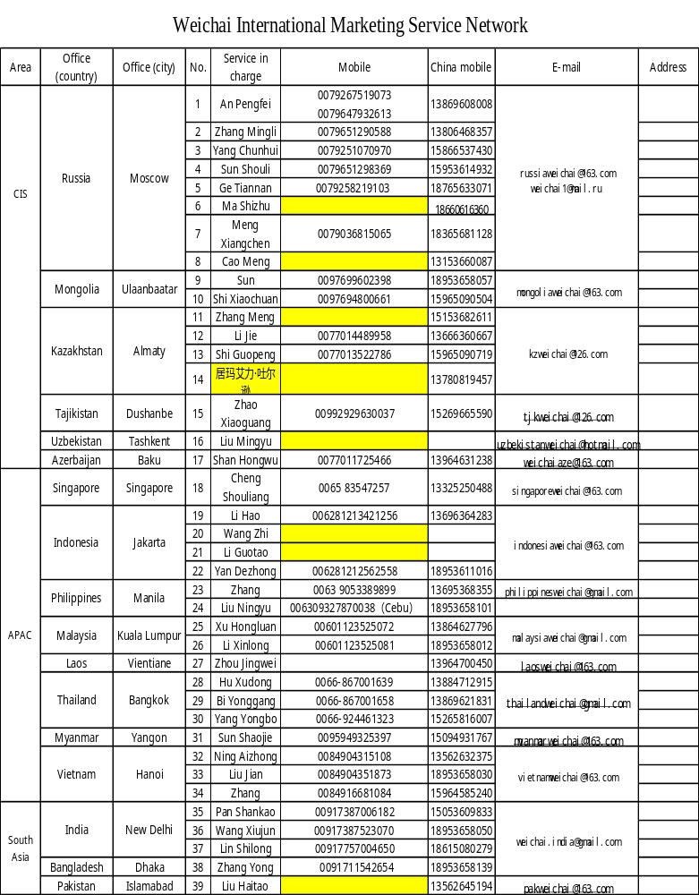

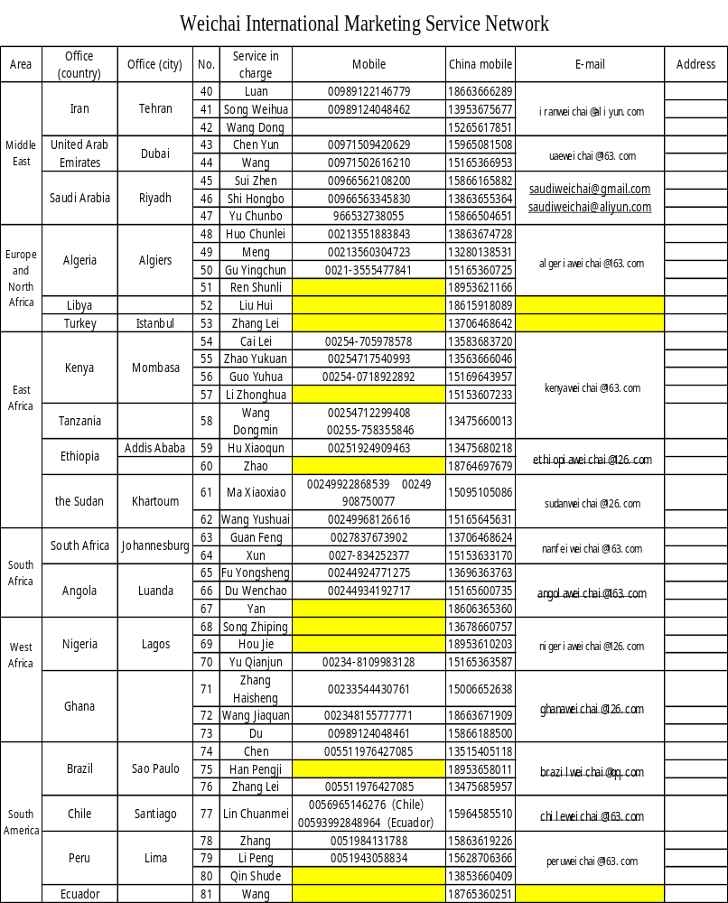

The European Union representative office
office address: Societe international des Moteurs Baudouin
CS50001 FR-13711 Cassis France
Linkman: Zhang Guoping (Paul. Zhang)
Mobile(in China): 008618953658085
Email: zhanggp@weichai.com

Diesel engine mandatory maintenance card
License plate number |  | Manufacturer |  | First copy Stub
User’s name |  | Diesel engine No. |  | First copy Stub
Detailed address |  | Date of mandatory maintenance |  | First copy Stub
Detailed address |  | Mileage of mandatory maintenance |  | First copy Stub
Purchaser |  | Purchasing date |  | First copy Stub
Identifier:  Official seal of service station: | Signature of user:  Valid documentation:  Phone: |  | Weichai Power special oil label: | First copy Stub
Friendly reminder: The mandatory maintenance card should be filled out triplicate and must be signed by the user. Omission of items will cause the card invalid.
Weichai Power supervisory phone: 400-6183066 800-8603066
After mandatory maintenance, this card and the Customer Satisfaction Questionnaire will be collected by the service station and submitted to the reginal office.

Diesel engine mandatory maintenance card
License plate number |  | Manufacturer |  | First copy Stub
User’s name |  | Diesel engine No. |  | First copy Stub
Detailed address |  | Date of mandatory maintenance |  | First copy Stub
Detailed address |  | Mileage of mandatory maintenance |  | First copy Stub
Purchaser |  | Purchasing date |  | First copy Stub
Identifier:  Official seal of service station: | Signature of user:  Valid documentation:  Phone: |  | Weichai Power special oil label: | First copy Stub
Friendly reminder: The mandatory maintenance card should be filled out triplicate and must be signed by the user. Omission of items will cause the card invalid.
Weichai Power supervisory phone: 400-6183066 800-8603066
After mandatory maintenance, this card and the Customer Satisfaction Questionnaire will be collected by the service station and submitted to the regional office.

Diesel engine mandatory maintenance card
License plate number |  | Manufacturer |  | First copy Stub
User’s name |  | Diesel engine No. |  | First copy Stub
Detailed address |  | Date of compulsory maintenance |  | First copy Stub
Detailed address |  | Mileage of compulsory maintenance |  | First copy Stub
Purchaser |  | Purchasing date |  | First copy Stub
Identifier:  Official seal of service station: | Signature of user:  Valid documentation:  Phone: |  | Weichai Power special oil label: | First copy Stub
Friendly reminder: The mandatory maintenance card should be filled out triplicate and must be signed by the user. Omission of items will cause the card invalid.
Weichai Power supervisory phone: 400-6183066 800-8603066
After mandatory maintenance, this card and the Customer Satisfaction Questionnaire will be collected by the service station and submitted to the regional office.
Diesel engine mandatory maintenance card
License plate number |  | Manufacturer |  | 2nd copy, kept by Weichai for filing
User’s name |  | Diesel engine No. |  | 2nd copy, kept by Weichai for filing
Detailed address |  | Date of mandatory maintenance |  | 2nd copy, kept by Weichai for filing
Detailed address |  | Mileage of mandatory maintenance |  | 2nd copy, kept by Weichai for filing
Purchaser |  | Purchasing date |  | 2nd copy, kept by Weichai for filing
Identifier:  Official seal of service station: | Signature of user:  Valid documentation:  Phone: |  | Weichai Power special oil label: | 2nd copy, kept by Weichai for filing
Friendly reminder: The mandatory maintenance card should be filled out triplicate and must be signed by the user. Omission of items will cause the card invalid.
Weichai Power supervisory phone: 400-6183066 800-8603066
After mandatory maintenance, this card and the Customer Satisfaction Questionnaire will be collected by the service station and submitted to the regional office.

Diesel engine mandatory maintenance card
License plate number |  | Manufacturer |  | 2nd copy, kept by Weichai for filing
User’s name |  | Diesel engine No. |  | 2nd copy, kept by Weichai for filing
Detailed address |  | Date of mandatory maintenance |  | 2nd copy, kept by Weichai for filing
Detailed address |  | Mileage of mandatory maintenance |  | 2nd copy, kept by Weichai for filing
Purchaser |  | Purchasing date |  | 2nd copy, kept by Weichai for filing
Identifier:  Official seal of service station: | Signature of user:  Valid documentation:  Phone: |  | Weichai Power special oil label: | 2nd copy, kept by Weichai for filing
Friendly reminder: The mandatory maintenance card should be filled out triplicate and must be signed by the user. Omission of items will cause the card invalid.
Weichai Power supervisory phone: 400-6183066 800-8603066
After mandatory maintenance, this card and the Customer Satisfaction Questionnaire will be collected by the service station and submitted to the regional office.

Diesel engine mandatory maintenance card
License plate number |  | Manufacturer |  | 2nd copy, kept by Weichai for filing
User’s name |  | Diesel engine No. |  | 2nd copy, kept by Weichai for filing
Detailed address |  | Date of mandatory maintenance |  | 2nd copy, kept by Weichai for filing
Detailed address |  | Mileage of mandatory maintenance |  | 2nd copy, kept by Weichai for filing
Purchaser |  | Purchasing date |  | 2nd copy, kept by Weichai for filing
Identifier:  Official seal of service station: | Signature of user:  Valid documentation:  Phone: |  | Weichai Power special oil label: | 2nd copy, kept by Weichai for filing
Friendly reminder: The mandatory maintenance card should be filled out triplicate and must be signed by the user. Omission of items will cause the card invalid.
Weichai Power supervisory phone: 400-6183066 800-8603066
After mandatory maintenance, this card and the Customer Satisfaction Questionnaire will be collected by the service station and submitted to the regional office.
Diesel engine mandatory maintenance card
License plate number |  | Manufacturer |  | 3rd copy, kept by the service station
User’s name |  | Diesel engine No. |  | 3rd copy, kept by the service station
Detailed address |  | Date of mandatory maintenance |  | 3rd copy, kept by the service station
Detailed address |  | Mileage of mandatory maintenance |  | 3rd copy, kept by the service station
Purchaser |  | Purchasing date |  | 3rd copy, kept by the service station
Identifier:  Official seal of service station: | Signature of user:  Valid documentation:  Phone: |  | Weichai Power special oil label: | 3rd copy, kept by the service station
Friendly reminder: The mandatory maintenance card should be filled out triplicate and must be signed by the user. Omission of items will cause the card invalid.
Weichai Power supervisory phone: 400-6183066 800-8603066
After mandatory maintenance, this card and the Customer Satisfaction Questionnaire will be collected by the service station and submitted to the regional office.

Diesel engine mandatory maintenance card
License plate number |  | Manufacturer |  | 3rd copy, kept by the service station
User’s name |  | Diesel engine No. |  | 3rd copy, kept by the service station
Detailed address |  | Date of mandatory maintenance |  | 3rd copy, kept by the service station
Detailed address |  | Mileage of mandatory maintenance |  | 3rd copy, kept by the service station
Purchaser |  | Purchasing date |  | 3rd copy, kept by the service station
Identifier:  Official seal of service station: | Signature of user:  Valid documentation:  Phone: |  | Weichai Power special oil label: | 3rd copy, kept by the service station
Friendly reminder: The mandatory maintenance card should be filled out triplicate and must be signed by the user. Omission of items will cause the card invalid.
Weichai Power supervisory phone: 400-6183066 800-8603066
After mandatory maintenance, this card and the Customer Satisfaction Questionnaire will be collected by the service station and submitted to the regional office.

Diesel engine mandatory maintenance card
License plate number |  | Manufacturer |  | 3rd copy, kept by the service station
User’s name |  | Diesel engine No. |  | 3rd copy, kept by the service station
Detailed address |  | Date of mandatory maintenance |  | 3rd copy, kept by the service station
Detailed address |  | Mileage of mandatory maintenance |  | 3rd copy, kept by the service station
Purchaser |  | Purchasing date |  | 3rd copy, kept by the service station
Identifier:  Official seal of service station: | Signature of user:  Valid documentation:  Phone: |  | Weichai Power special oil label: | 3rd copy, kept by the service station
Friendly reminder: The mandatory maintenance card should be filled out triplicate and must be signed by the user. Omission of items will cause the card invalid.
Weichai Power supervisory phone: 400-6183066 800-8603066
After mandatory maintenance, this card and the Customer Satisfaction Questionnaire will be collected by the service station and submitted to the regional office.

Customer Satisfaction Questionnaire
Item | Evaluation factor | Excellent | Good | Acceptable | Bad | Not acceptable
Diesel engine product quality | Appearance
Diesel engine product quality | Performance
Diesel engine product quality | Reliability
Diesel engine delivery quality | Engine completeness
Diesel engine delivery quality | Attached spare parts and tools
Diesel engine delivery quality | Attached engine documents
Diesel engine delivery quality | Delivery time
Diesel engine service quality | Service promptness
Diesel engine service quality | Service quality
Diesel engine service quality | Service attitude
Others | Customer cancellation
Others | Return of products
Others | Additional transportation
Others | Other opinions of users
Customer’s seal
MM, DD, YY
Customer Service Center, Weichai Power Co., Ltd.
Address: No. 26 Minsheng East Street, Kuiwen District, Weifang City, Shandong Province
Zip code: 261001
Phone: 400-6183066 (for mobile phone or landline) 800-8603066 (for landline)
Fax: 0536-8235369

Note: please mark the “√” in the corresponding “column”.

